Ngô Ngọc Bảo Châu

1150080044

11_ĐH_THMT

Layout Activity_main.xml

<?xml version="1.0" encoding="utf-8"?>  
<LinearLayout xmlns:android="http://schemas.android.com/apk/res/android"  
 android:layout_width="match_parent"  
 android:layout_height="match_parent"  
 android:orientation="vertical"  
 android:padding="16dp"  
 android:gravity="top|center_horizontal">  
  
 <TextView  
 android:id="@+id/tvWorking"  
 android:layout_width="match_parent"  
 android:layout_height="wrap_content"  
 android:text="Working..."  
 android:textStyle="bold"  
 android:textSize="18sp"  
 android:layout_marginBottom="8dp"/>  
  
 <ProgressBar  
 android:id="@+id/pbFirst"  
 style="?android:attr/progressBarStyleHorizontal"  
 android:layout_width="match_parent"  
 android:layout_height="8dp"  
 android:layout_marginBottom="4dp"/>  
  
 <TextView  
 android:id="@+id/tvPercent"  
 android:layout_width="wrap_content"  
 android:layout_height="wrap_content"  
 android:text="0%"  
 android:textStyle="bold"  
 android:layout_marginBottom="8dp"/>  
  
 <TextView  
 android:id="@+id/tvReturn"  
 android:layout_width="match_parent"  
 android:layout_height="wrap_content"  
 android:text="Returned by background thread:"  
 android:textSize="16sp"  
 android:layout_marginBottom="16dp" />  
  
 <Button  
 android:id="@+id/btnStart"  
 android:layout_width="wrap_content"  
 android:layout_height="wrap_content"  
 android:text="Start" />  
  
 <ProgressBar  
 android:id="@+id/pbSecond"  
 android:layout_width="40dp"  
 android:layout_height="40dp"  
 android:layout_marginTop="16dp"/>  
</LinearLayout>

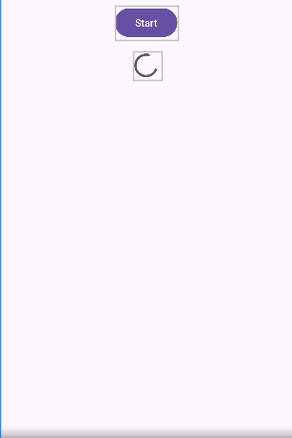

MainActivity.java

package com.example.bailab;  
  
import android.os.Bundle;  
import android.os.Handler;  
import android.os.Looper;  
import android.os.Message;  
import android.view.View;  
import android.widget.Button;  
import android.widget.ProgressBar;  
import android.widget.TextView;  
  
import androidx.appcompat.app.AppCompatActivity;  
  
import java.util.Random;  
  
public class MainActivity extends AppCompatActivity {  
  
 private TextView tvWorking, tvReturn, tvPercent;  
 private ProgressBar pbFirst, pbSecond;  
 private Button btnStart;  
  
 private boolean isRunning = false;  
 private final int maxSec = 10; // chạy 10 bước, mỗi bước 1s  
 private int intTest = 0;  
 private Thread bgThread;  
  
 private final Handler uiHandler = new Handler(Looper.*getMainLooper*()) {  
 @Override public void handleMessage(Message msg) {  
 String returnedText = (String) msg.obj;  
 tvReturn.setText(returnedText);  
 pbFirst.setProgress(msg.arg1);  
 tvPercent.setText((msg.arg1 * 10) + "%");  
  
 if (msg.arg1 >= maxSec) {  
 tvWorking.setText(getString(R.string.*done_background_thread_has_been_stopped*));  
 pbSecond.setVisibility(View.*GONE*); // tắt spinner khi xong  
 btnStart.setEnabled(true); // mở lại nút  
 } else {  
 tvWorking.setText(getString(R.string.*working*));  
 }  
 }  
 };  
  
 @Override protected void onCreate(Bundle savedInstanceState) {  
 super.onCreate(savedInstanceState);  
 setContentView(R.layout.*activity_main*);  
  
 tvWorking = findViewById(R.id.*tvWorking*);  
 tvReturn = findViewById(R.id.*tvReturn*);  
 tvPercent = findViewById(R.id.*tvPercent*);  
 pbFirst = findViewById(R.id.*pbFirst*);  
 pbSecond = findViewById(R.id.*pbSecond*);  
 btnStart = findViewById(R.id.*btnStart*);  
  
 pbFirst.setMax(maxSec);  
 pbSecond.setIndeterminate(true);  
 pbSecond.setVisibility(View.*GONE*); // ẩn spinner lúc đầu  
  
 btnStart.setOnClickListener(v -> {  
 if (bgThread == null || !bgThread.isAlive()) startBackgroundThread();  
 });  
 }  
  
 private void startBackgroundThread() {  
 isRunning = true;  
 intTest = 0;  
  
 btnStart.setEnabled(false); // khóa nút khi chạy  
 pbSecond.setVisibility(View.*VISIBLE*); // hiện spinner  
 pbFirst.setProgress(0);  
 tvPercent.setText("0%");  
 tvWorking.setText(getString(R.string.*working*));  
 tvReturn.setText(getString(R.string.*returned_by_bg_thread*));  
  
 bgThread = new Thread(() -> {  
 try {  
 Random random = new Random();  
 for (int i = 1; i <= maxSec; i++) {  
 if (!isRunning) break;  
 Thread.*sleep*(1000);  
 int rnd = random.nextInt(101);  
 intTest += 1;  
  
 String data = getString(R.string.*returned_by_bg_thread*)  
 + "\n\nThread value: " + rnd  
 + " Global value seen: " + intTest;  
  
 Message msg = Message.*obtain*();  
 msg.obj = data;  
 msg.arg1 = i; // tiến độ  
 uiHandler.sendMessage(msg);  
 }  
 } catch (InterruptedException ignored) {  
 } finally {  
 Message done = Message.*obtain*();  
 done.obj = getString(R.string.*done_background_thread_has_been_stopped*);  
 done.arg1 = maxSec;  
 uiHandler.sendMessage(done);  
 isRunning = false;  
 }  
 });  
 bgThread.start();  
 }  
  
 @Override protected void onStop() {  
 super.onStop();  
 isRunning = false;  
 if (bgThread != null && bgThread.isAlive()) bgThread.interrupt();  
 }  
}

Thêm strings.xml

<resources>  
 <string name="app_name">BaiLab</string>  
 <string name="start">Start</string>  
 <string name="working">Working...</string>  
 <string name="returned_by_bg_thread">Returned by background thread:</string>  
 <string name="done_background_thread_has_been_stopped">Done\nBackground thread has been stopped</string>  
  
 <!-- nếu project còn các file menu/nav mặc định cần chuỗi này, thêm để tránh AAPT lỗi -->  
 <string name="action_settings">Settings</string>  
 <string name="first_fragment_label">First Fragment</string>  
 <string name="second_fragment_label">Second Fragment</string>  
</resources>

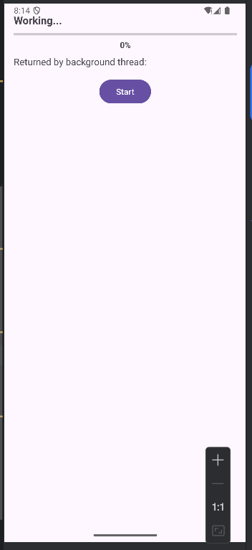

sau khi chạy working xong.

